Pedestrian Tracking in Dynamic Urban Scenes Using YOLO11x and OC-SORT with Camera-Motion Compensation
Benjamin Jakupović, Damjan Đekić, Kristina Host, Marina Ivašić-Kos
Faculty of Informatics and Digital Technologies, University of Rijeka, Rijeka, Croatia†
benjamin.jakupovic@student.uniri.hr, damjan.djekic@student.uniri.hr, kristina.host@inf.uniri.hr, marinai@uniri.hr

Abstract—Reliable automatic detection and tracking of pedestrians is important for traffic safety and autonomous driving, yet remains challenging in dynamic urban scenes. Clustered backgrounds, occlusions, pedestrians moving in different directions at varying distances, and continuous ego-motion of the camera often lead to fragmented trajectories and identity switches, which degrade the system’s ability to anticipate pedestrian intent. This paper investigates and compares several tracking strategies, ranging from Kalman-filter-based single-object trackers to modern multiple-object tracking approaches such as Norfair, DeepSORT, and OC-SORT, and proposes enhancements that compensate for camera motion and improve tracking through occlusions. The proposed modifications reduce identity switches and extend the duration of consistent pedestrian tracks. Experiments on the MOT17 benchmark demonstrate that the best performance, with MOTA of 40.4% and IDF1 of 51.7%, is achieved by a configuration that combines a YOLO11x detector with the OC-SORT tracker augmented by ByteTrack association logic and a camera-motion compensation (CMC) module. These results indicate that reliable perception for autonomous driving requires coupling robust object detection with explicit camera-motion modelling and advanced data-association techniques within the MOT pipeline.
Keywords—computer vision; person detection; person tracking; YOLO architecture; OC-SORT algorithm; ByteTrack algorithm; CMC algorithm

Introduction
Multiple Object Tracking (MOT) is a fundamental component of modern perception systems, particularly in autonomous driving and intelligent transportation, where reliable and temporally consistent tracking of pedestrians is essential for safe navigation and decision making. Unlike single-frame object detection, MOT must maintain object identities over time under challenging real-world conditions such as frequent occlusions, illumination changes, viewpoint variations, and camera motion, which are especially pronounced in dense urban environments. In such scenes, pedestrians exhibit highly variable and often unpredictable motion patterns, including sudden changes in direction, varying speeds, and complex interactions with other agents, which substantially increase tracking complexity and the risk of safety-critical situations [1]. Consequently, accurate detection combined with robust long-term tracking of pedestrians is a key requirement for collision avoidance, motion planning, and higher-level scene understanding and intent prediction in autonomous vehicles [2].
Recent advances in deep learning have significantly improved person and pedestrian detection performance, even under adverse conditions with cluttered backgrounds, limited visibility [3], and dynamic scenes [4]. However, in real-world traffic scenarios, tracking quality is still strongly affected by frequent occlusions, dense crowds, strong perspective effects [5], and the continuous ego-motion of the camera, which induces apparent background motion that complicates motion modelling and data association [6]. These factors often lead to fragmented trajectories and identity switches, degrading the reliability of downstream perception and decision-making modules in autonomous driving stacks [7].
Traditional tracking approaches based on linear motion models and Kalman filtering provide computational efficiency, but typically fail in crowded scenes and under long occlusions [7]. That motivated tracking-by-detection pipelines that combine deep neural detectors with more advanced data-association strategies [8]. Some of modern MOT methods are Norfair [17], DeepSORT [16], ByteTrack, [10] and OC-SORT (Observation-Centric SORT) [11]. By design, their performance depends largely on the quality of the detector, the association logic and the proper selection of hyperparameters. In addition, several studies have shown that even state-of-the-art tracking methods show significant performance degradation when camera motion is not explicitly modeled [6], [7], [9].
The goal of this paper is to systematically evaluate and enhance pedestrian tracking performance in dynamic urban environments using using MOTChallenge benchmark [14] that provides diverse urban video sequences with annotated pedestrian trajectories and a common evaluation protocol, making it a widely adopted reference for pedestrian MOT research.
We investigate several tracking configurations that combine a YOLOv11 detector with modern trackers and alternative association strategies, and we introduce a camera-motion compensation module designed to better handle ego-motion-induced background changes. In particular, we study how design choices such as detector confidence thresholds, input resolution, data-association logic, interpolation of missing detections, and explicit camera-motion compensation affect standard MOT metrics, with a focus on improving MOTA and IDF1.
The remainder of the paper is organized as follows: Section II details the proposed tracking pipeline, including the YOLO11x detector, OC-SORT framework, and camera-motion compensation. Section III presents the experimental setup, MOT17 dataset configuration, and quantitative results. Section IV presents and discussed the experimental results and Section V concludes the paper and outlines directions for future research.

Proposed Tracking System
We examined different configurations of pedestrian tracking method based on automatic detection and tracking algorithm and proposed a system that integrates YOLO11x object detector with improved OC-SORT tracker.
OC-SORT is observation-oriented and to improve tracking performance in challenging dynamic urban scenes, we improved the detection association strategy and added interpolation and camera motion compensation to reduce camera drift during recording.
The tracking core is based on the OC-SORT algorithm, which we extended with three components:
- Camera Motion Compensation (CMC),
- ByteTrack Association Logic,
- Trajectory Interpolation.
We implemented the CMC module using the Lucas-Kanade optical flow method [12] to separate ego-motion (e.g. dashboard cameras) from pedestrian motion. Features are tracked between consecutive frames to estimate an affine transformation matrix (translation, rotation, and scaling). This transformation is applied to the Kalman filter state vector (position and velocity) before the prediction step, ensuring that the motion model takes into account the camera motion.
To mitigate the fragmented trajectories caused by occlusion, we adopt a two-stage data association strategy from the ByteTrack algorithm [10]. High-confidence detections (score ≥ 0.5) are first associated using Intersection over Union (IoU). The remaining low-confidence detections (0.05 ≤ score < 0.5) are then compared to the mismatched tracks [10]. This allows tracking of partially occluded or blurred objects, which typically show lower detection scores.
Additionally, linear trajectory interpolation was applied post-processing to fill gaps in trajectories up to 20 frames long, which significantly improved the recall of the system.

Experimental Setup
The experiment was designed with incremental changes to gain insight into which system components and mechanisms provide the most significant improvements under realistic constraints. First, the baseline tracking model configurations were tested, combining different detectors and tracking algorithms and then individual tracking components were tested to isolate their contribution to performance.

Detection and tracking methods
For the detector, we used l and x model variants from the YOLOv11 family [13], both previously trained on the COCO dataset without additional fine-tuning. For detection phase in tracking we have also tested performance of segmentation model Segment Anything Model 2 (SAM2) [15].
Then, we tested detection models as an integral component of selected modern tracking algorithms: Norfair, DeepSORT, OC-SORT, and ByteTrack and then on the best performing model we examined how various parameters such as detector confidence thresholds, input image resolution, associated detection association strategies, and camera motion interpolation and compensation affect the overall tracking performance

Evaluation dataset
We performed the evaluation on the MOT17 benchmark, a part of MOTChallenge benchmark [14], which includes diverse urban scenes captured by a surveillance camera and a motion camera with pedestrians and vehicles in motion, moving individually and in groups, entering and exiting the camera's field of view from different directions, at different distances from the camera. An example of images from the MOT17 dataset is shown in Fig 1.


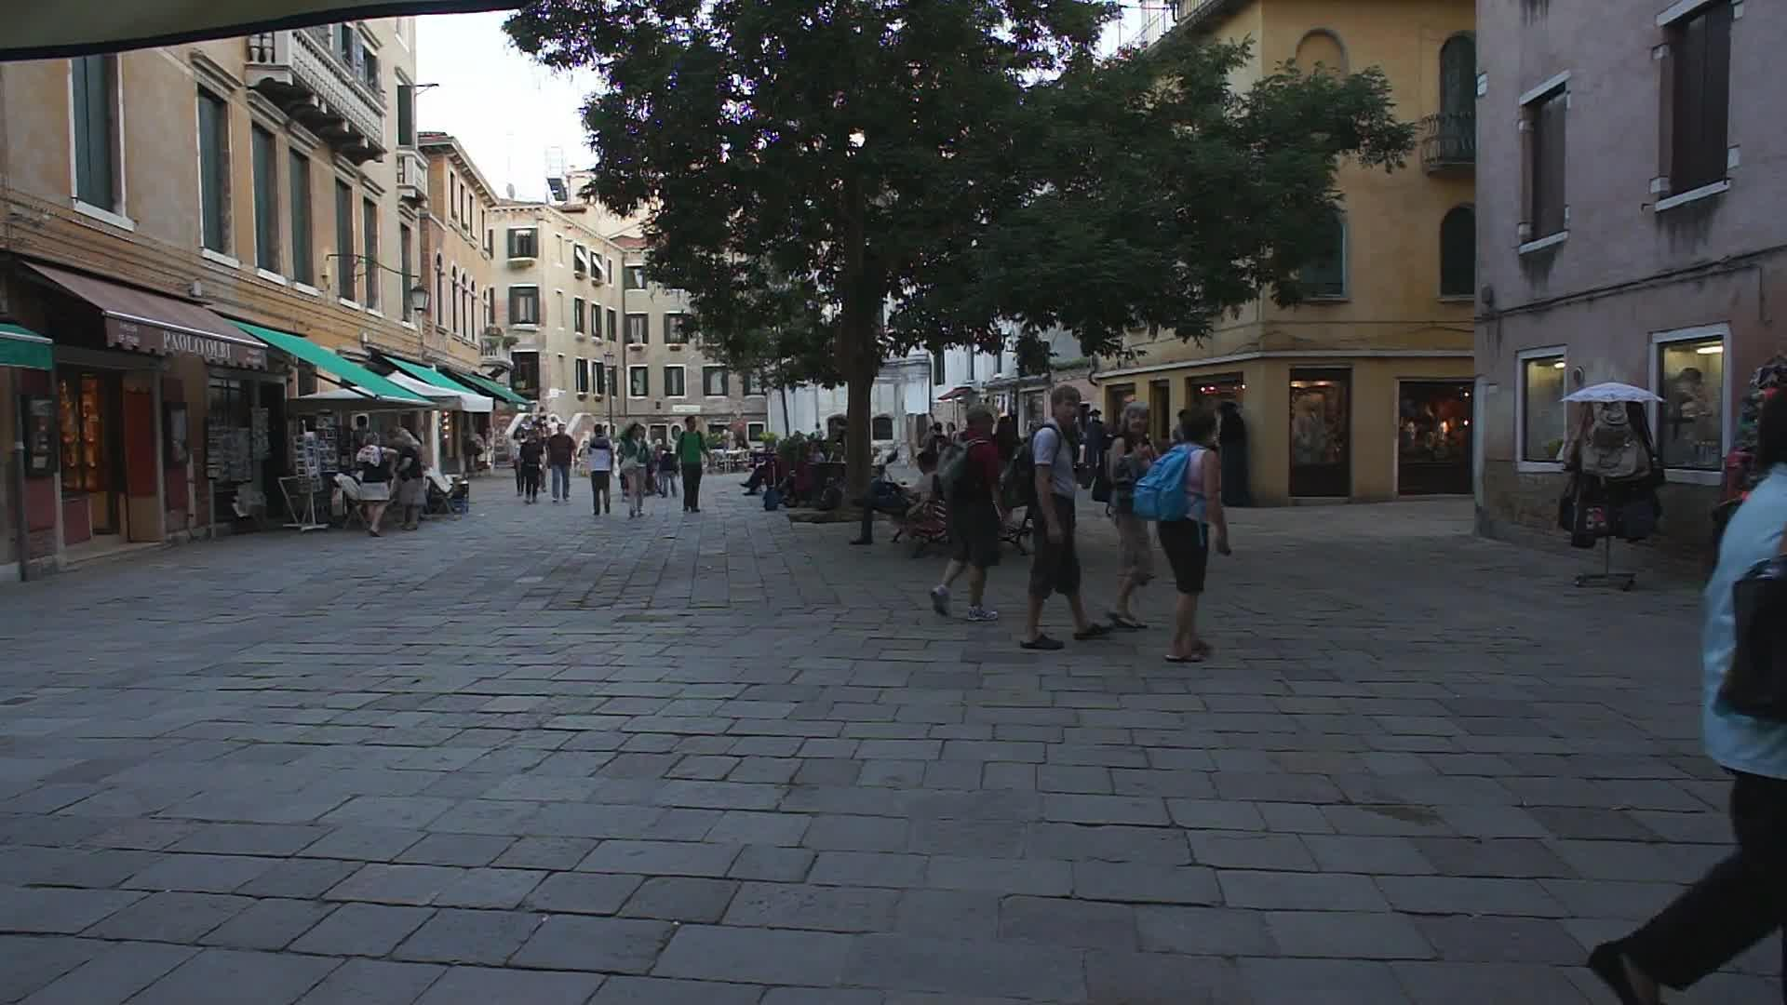
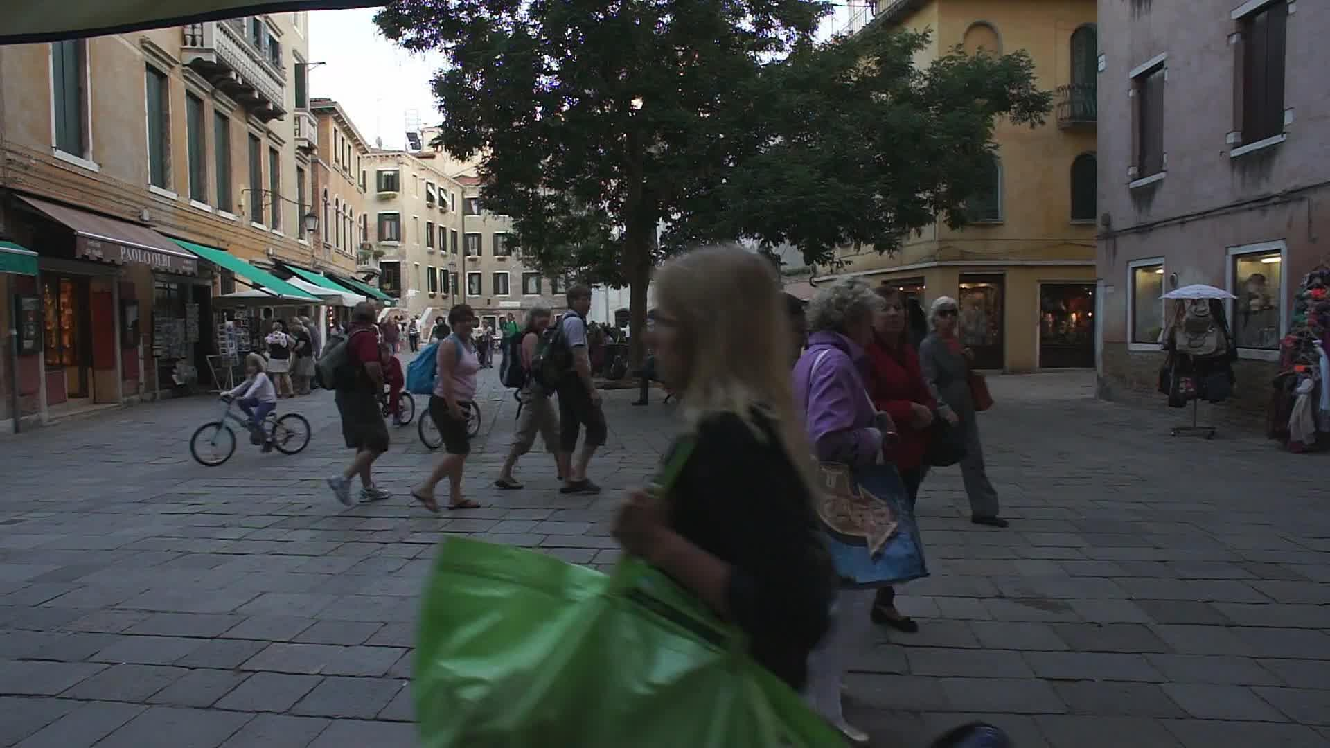
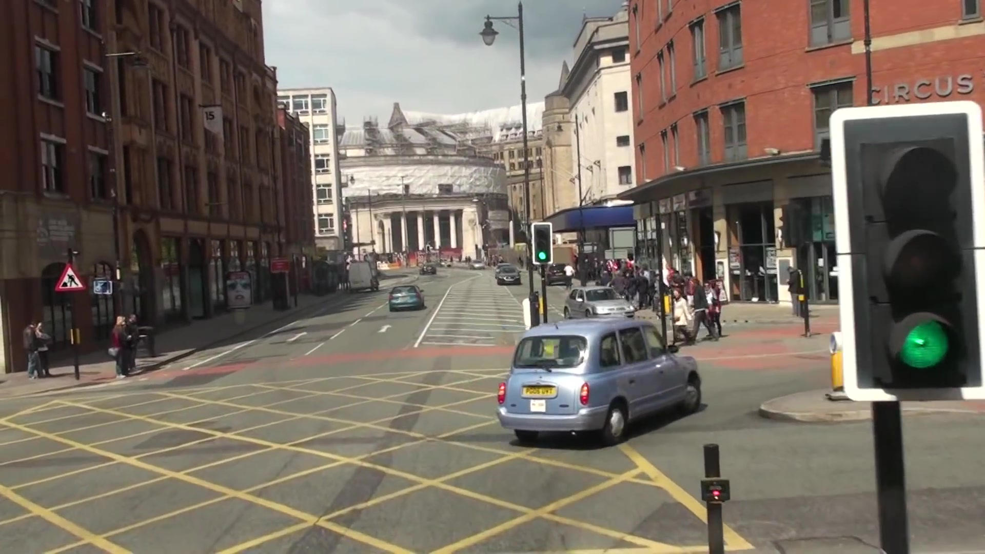

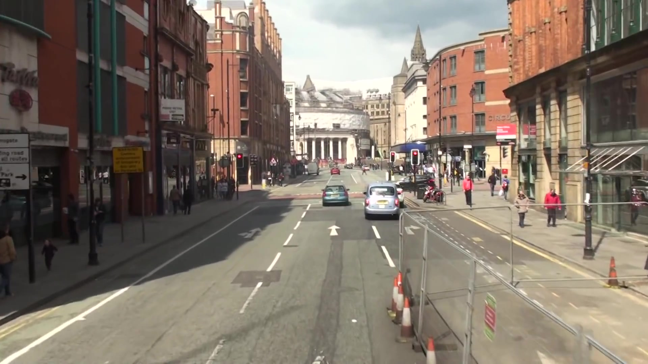
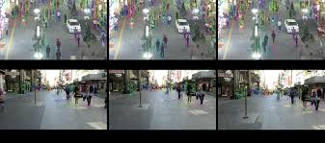

Figure 1. An example of images from the MOT17 dataset
Video sequences in MOT17 are annotated with pedestrian trajectories and accompanied by ground truth detections at the bounding box level from multiple detectors. To adapt the MOT17 dataset for YOLO training and validation, we converted the ground truth annotations from the standard MOT format [frame, id, left, top, width, height] to the YOLO format [class, x_center, y_center, width, height], normalized by image dimensions. Only detection belonging to the Pedestrian class (Class ID 1 in MOT17) were used to perform a single-class testing of the model.
We set all images to an input image resolution of 1280 x 1280 pixels.

Evaluation metrics
The existing ground truth enables tacking evaluation using standard MOTA metrics including MOTA, MOTP, IDF1, IDP, IDR, precision, recall, and IDSW, that assess both detection quality and identity preservation.
A description of the metrics used is given in Table 1.
- Standard MOTA Metrics with Description
Metric | Description
MOTA | Multiple Object Tracking Accuracy - overall metric that takes into account FP, FN, and IDs.
MOTP | Multiple Object Tracking Precision - average overlap between the predicted frames and the ground truth.
Precision | Percentage of detected objects that are relevant
Recall | Percentage of ground truth objects that are correctly detected
IDF1 | Measures how consistently a tracker tracks the same object
ID Switches | Number of identity switches, number of times the tracker incorrectly changes the object ID
MT/ ML | Mostly Tracked trajectories and Mostly Lost trajectories
FP | False Positives detections
FN | False Negatives detections

While MOTA provides an overall accuracy measure, IDF1 is of particular importance in this study, as it directly reflects the ability of a tracker to preserve object identities over time that is an essential requirement for downstream autonomous driving applications.

EXPERIMENTAL RESULTS AND ANALYSIS

Comparison of tracker performance with YOLOv11 detector
The results of the initial testing of two versions of the YOLOv11 model l and x as an integral component of the selected tracking algorithms Norfair, DeepSORT, OC-SORT and ByteTrack are given in Table 1.
- Tracking results of tracking methods with YOLO11-l and YOLO11-x detectors on the MOT17 pedestrian class
Method | Prec | Rcll | IDF1 | ID Sw | MOTA | MOTP
YOLOv11- l detector
+ Norfair | 86.2% | 25.9% | 30.3% | 369 | 21.4% | 0.179
+ OC-SORT | 93.2% | 24.3% | 31.6% | 213 | 22.3% | 0.173
+ DeepSORT
+ ByteTrack | 90.7% | 38.8% | 45.4% | 204 | 34.6% | 0.191
YOLOv11-x detector
+ Norfair
+DeepSORT | 57.5% | 49.5% | 37.4% | 573 | 12.3% | 0.225
+ OC-SORT
+ ByteTrack

Initial baselines utilizing Norfair and DeepSORT yielded modest MOTA scores of 21.4% and 12.3%, respectively, highlighting the limitations of standard re-identification embeddings and Euclidean matching in crowded scenes.. In contrast, the OC-SORT algorithm demonstrated superior potential; starting from a baseline MOTA of 22.3%, performance was progressively enhanced through hyperparameter tuning (35.8%), the incorporation of ByteTrack association logic (34.6%), and trajectory interpolation (38.9%). Building upon these findings, this section documents the experimental evaluation of the proposed tracking pipeline on the MOT17 benchmark, focusing on the two most effective configurations to assess the impact of input resolution and the effectiveness of the integrated tracking components.

Improvements on the YOLOv11+OC-SORT algorithm

Detector Performance

The performance of the YOLO11x detector was validated on the prepared subset of the MOT17 dataset. The precision-recall curves are presented below.
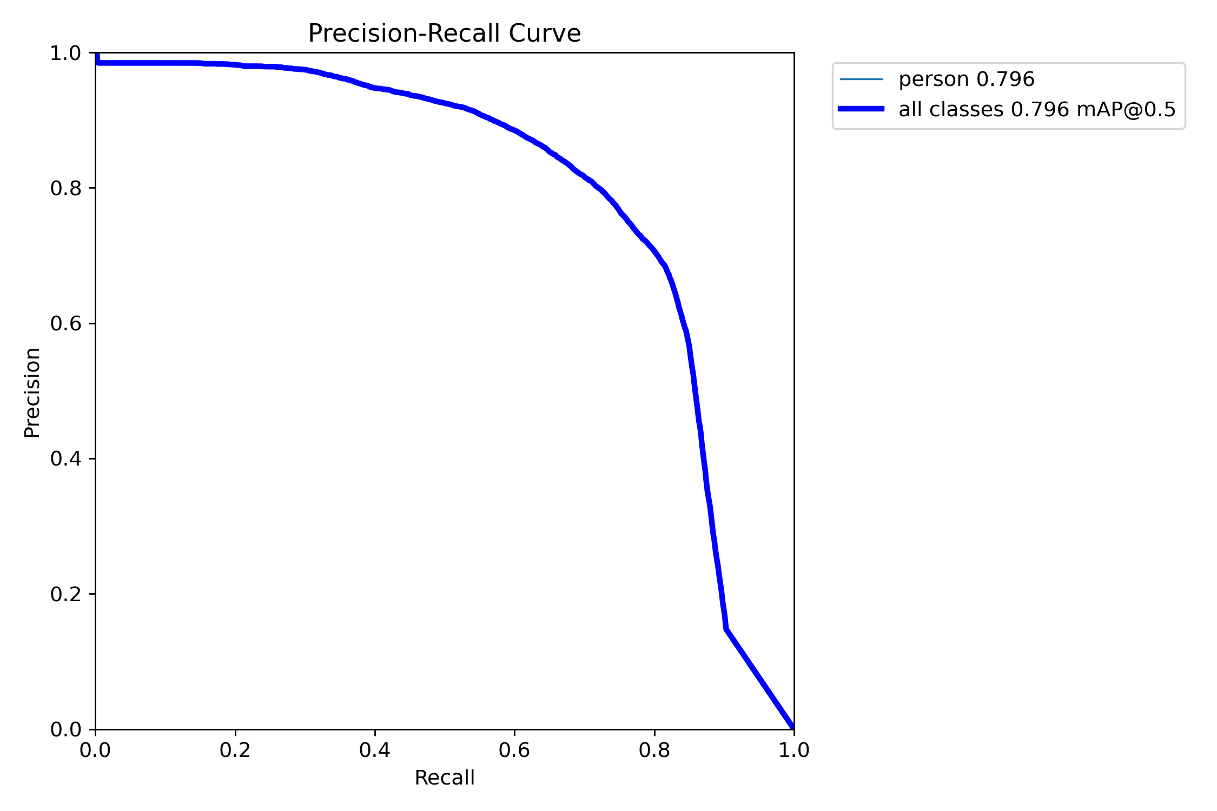
Figure 1: Precision-Recall Curve demonstrating the detectors trade-off between false positives and false negatives

As indicated by the validation artifacts in Fig. 1 and Fig. 2, the detector achieves a robust balance between precision and recall. The high true positive rate is crucial for the subsequent tracking stage, as the OC-SORT algorithm relies heavily on the quality of observations to correct its momentum-based predictions.
Additional details can be seen by analyzing the model's F1, P and R curves.
Figure 3 depicts the F1-Confidence curve, illustrating the harmonic mean of precision and recall across varying confidence thresholds. The curve exhibits a stable plateau, indicating that the detector's performance is robust to threshold variations. The peak F1 score suggests an optimal trade-off point, which informs the selection of the high-confidence threshold (0.5) used in our tracking experiments. This ensures that the primary tracking associations are grounded in high-quality detections, while the subsequent association stages can exploit the higher recall available at lower confidence levels.
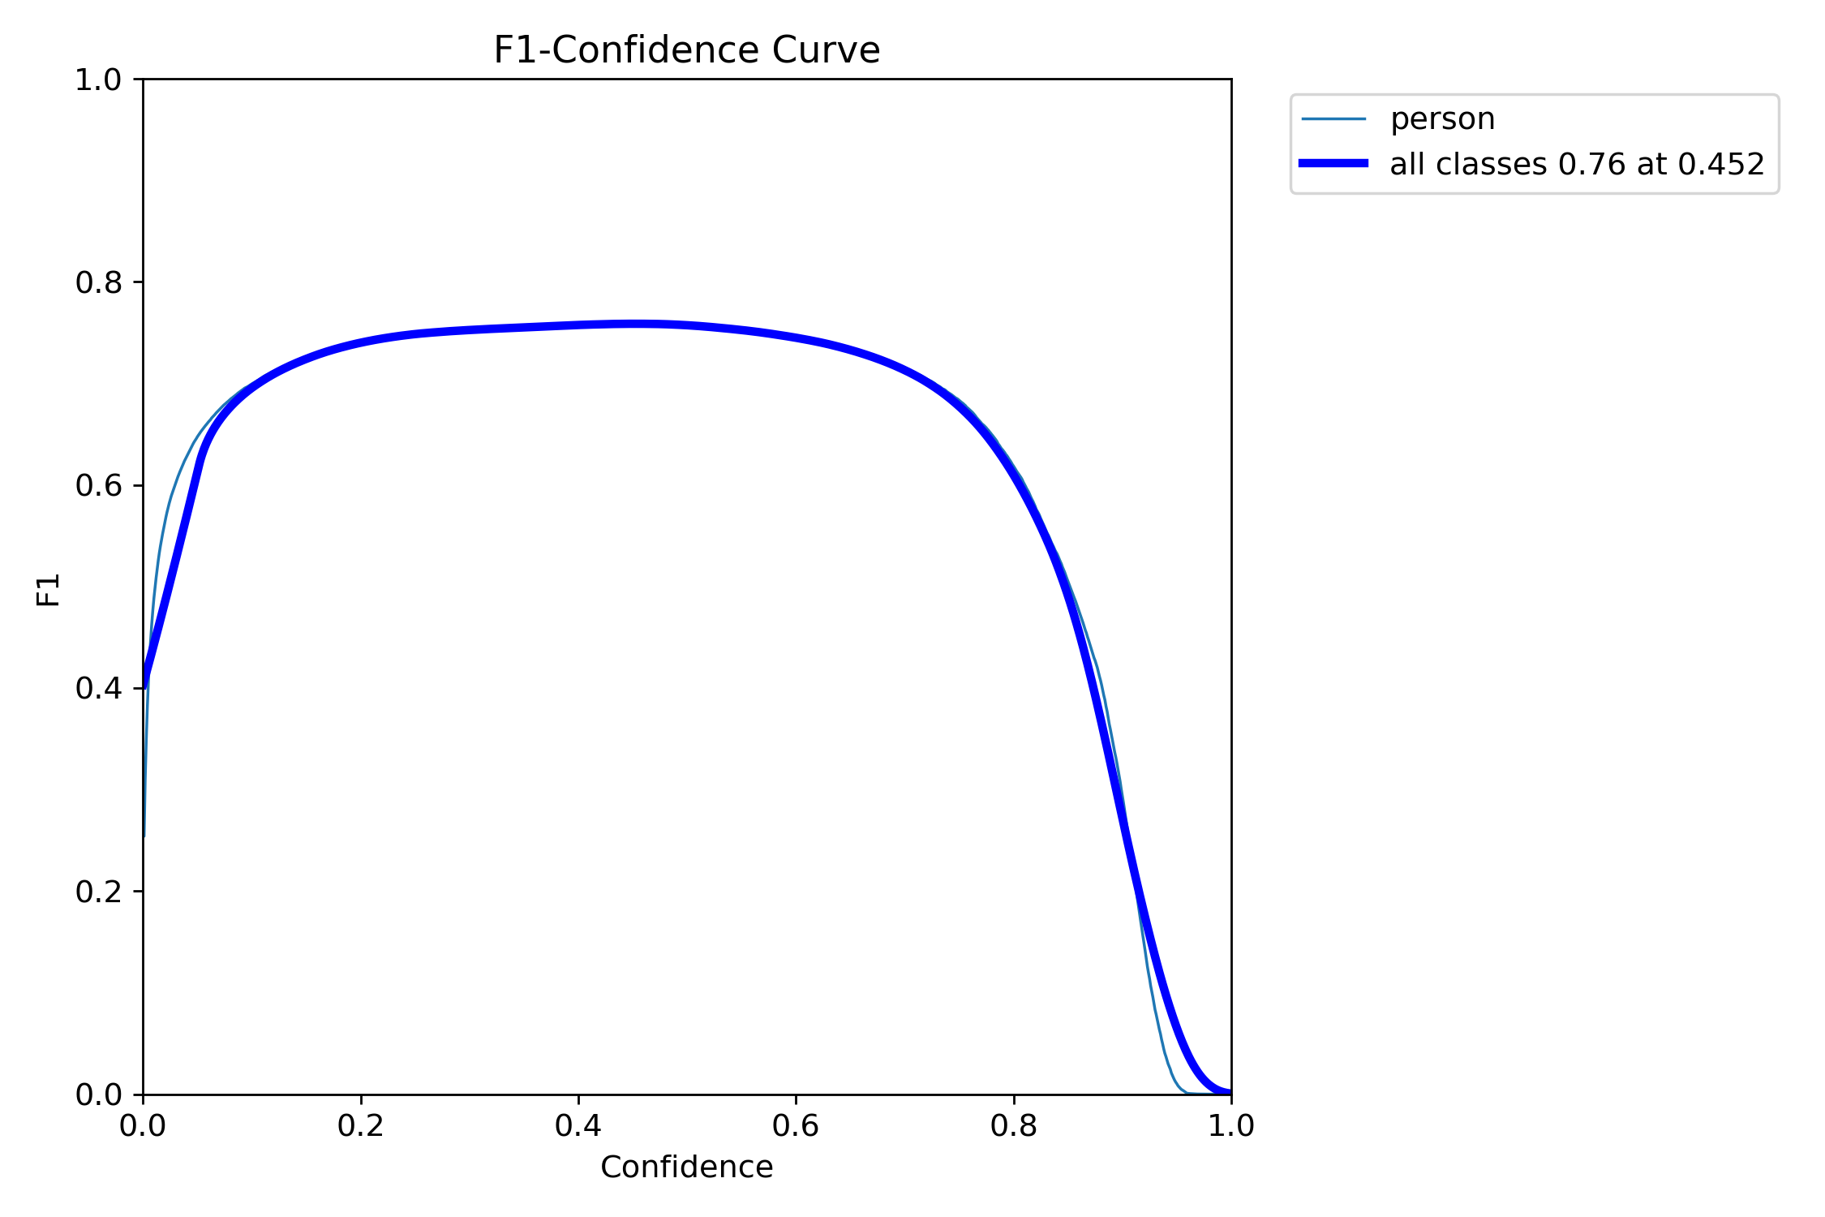
Figure 2: F1-Confidence Curve. The curve demonstrates the optimal confidence threshold for maximizing the harmonic mean of precision and recall

Figure 4 presents the Precision-Confidence curve, which characterizes the detector's reliability across the confidence spectrum. The curve demonstrates a monotonic increase in precision as the confidence threshold rises, indicating effective suppression of false positives at higher scores. At the operational threshold of 0.5, the detector achieves a precision significantly above 0.8, ensuring that the initial tracking candidates are of high quality. This high-precision regime is critical for the OC-SORT tracker, as it reduces the likelihood of initializing false tracks or incorrectly updating existing Kalman filters with background noise.
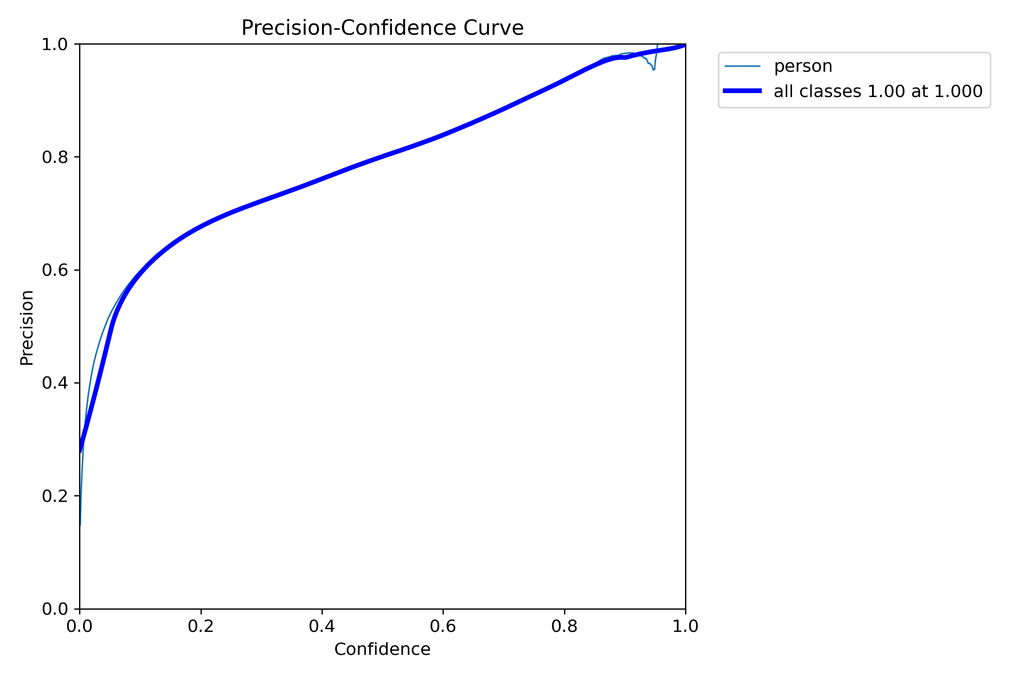
Figure 3: Precision-Confidence Curve. The monotonic rise in precision validates the model’s ability to filter false positives at higher confidence levels

Finally, Fig. 5 illustrates the Recall-Confidence curve, showing the inverse relationship between confidence and recall. As the confidence threshold increases, the system naturally retrieves fewer ground truth objects. While a threshold of 0.5 reduces the raw detection recall, this trade-off is mitigated by the ByteTrack algorithm, which specifically recovers low-confidence detections (0.1 to 0.5) during the second association stage. This hierarchical approach allows the system to maintain high precision for track initialization while preserving recall for ongoing trajectories.
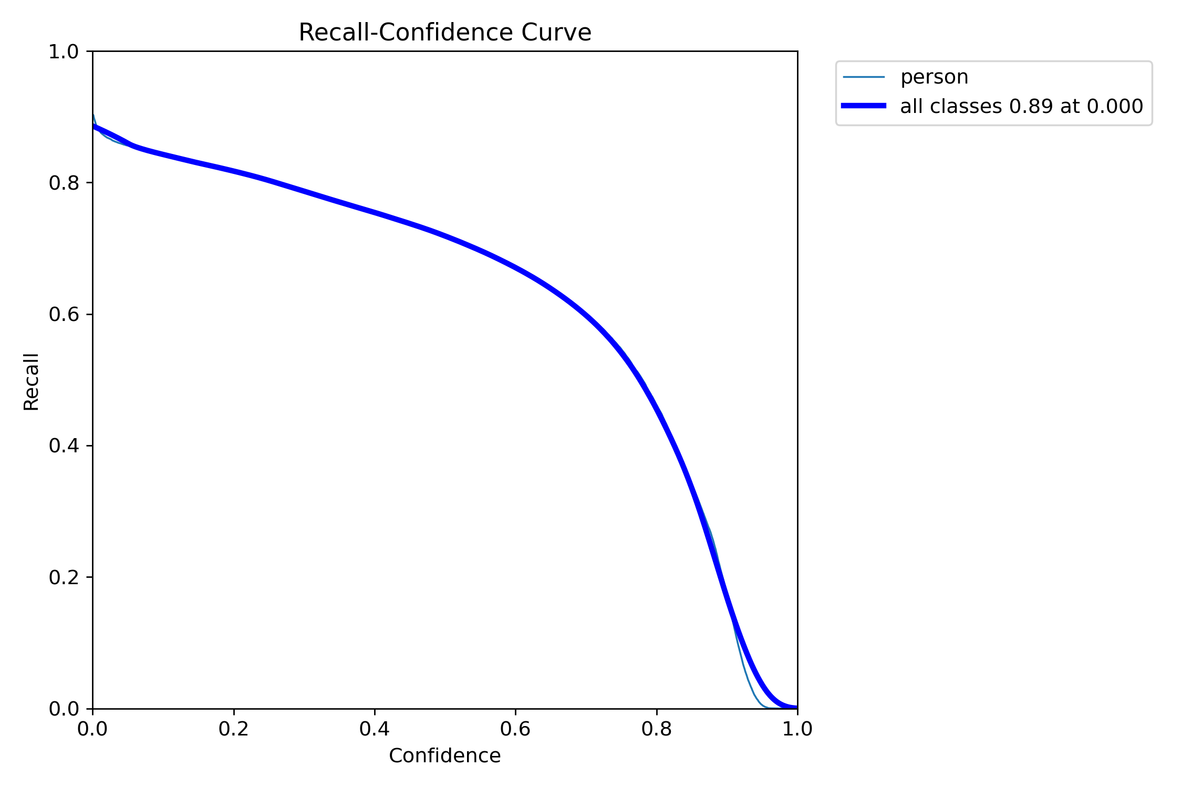
Figure 4: Recall-Confidence Curve. The decline in recall at higher thresholds is compensated by the multi-stage association logic of ByteTrack

The results are summarized in Table I.
- Tracking Performance on MOT17
Metric | YOLO11x (IOU/CONFIDENCE>0.5)+ OC-SORT | YOLO11x (IOU/CONFIDENCE>0.4)+ OC-SORT | + ByteTrack | + CMC
MOTA | 40.4% | 40.4%
IDF1 | 51.7% | 51.7%
Recall | 51.4% | 51.4%
Precision | 82.7% | 82.7%
ID Switches | 276 | 276
MT | 138 | 138
ML | 141 | 141
FP | 9,744 | 9,744
FN | 44,028 | 44,028

The configuration achieved a MOTA of 40.4% and an IDF1 of 51.7%. Notably, the inclusion of Camera Motion Compensation and ByteTrack logic resulted in a relatively low number of ID switches (276) compared to baseline methods evaluated in preliminary studies. The high precision (82.7%) suggests that the detector and the association logic effectively filter out background noise. The recall of 51.4% indicates that the interpolation and low-confidence matching successfully recovered a significant portion of pedestrian trajectories that would otherwise be lost due to occlusion.

Increasing input image resolution
Experiment 11 utilized the identical pipeline as Experiment 10 (YOLO11x + OC-SORT + ByteTrack + CMC + Interpolation) but increased the input inference resolution from 1280 x 1280 to 1920 x 1920 pixels. The objective was to determine if higher resolution input yields a proportional increase in tracking accuracy by resolving smaller or distant pedestrians.

Performance comparison when input image resolution was increased are presented in Table II.
- Comparison of Experiment 11 (1920px) vs. Experiment 19 (1280px)
Metric | 1920px | 1280px | Delta
MOTA | 40.7% | 40.4% | +0.3%
IDF1 | 52.1% | 51.7% | +0.4%
Recall | 50.5% | 51.4% | -0.9%
Precision | 84.2% | 82,7% | +1.5%
ID Switches | 306 | 276 | +30
FP | 8,610 | 9,744 | -1,134
FN | 44,871 | 44,028 | +843

Increasing the resolution to 1920px resulted in marginal gains in the primary composite metrics, with MOTA increasing by only 0.3% and IDF1 by 0.4%.
Interestingly, the recall decreased slightly (from 51.4% to 50.5%), while precision improved (from 82.7% to 84.2%). This suggests that while the higher resolution allows the model to be more selective, reducing False Positives by over 1,000, it also leads to the suppression of some valid detections, possibly due to changes in the effective anchor scales or confidence calibration at higher resolutions. Furthermore, the number of ID switches increased from 276 to 306, indicating slightly less stable identity maintenance.
We conclude that the configuration from Experiment 10 (1280px) is superior for practical deployment. The marginal improvement in MOTA observed in Experiment 11 does not justify the significantly higher computational cost associated with processing 1920 x 1920 images (a 2.25x increase in pixel count). The 1280px setup offers a better balance between recall and precision, maintains more stable identities (fewer ID switches), and operates with greater computational efficiency, making it the better choice for autonomous driving systems where real-time processing is a constraint.

Evaluation on Public Detections

Experimental Setup

To assess the tracker's performance within the constraints of the MOT17 "Public Detection" track, we decoupled the YOLO11x detector and utilized the standard detections provided by the benchmark. These detections originate from three different detectors: DPM, FRCNN, and SDP, and are provided for the test set sequences. The tracking pipeline utilized the identical configuration as Experiment 10 (OC-SORT + ByteTrack + CMC + Interpolation), ensuring a direct evaluation of the tracker's capability to handle diverse detection qualities. The system achieved an average processing speed of 31.08 Hz during this evaluation.
The results on the MOT17 test set using public detections are summarized in Table III. The metrics represent the combined performance across all sequences and detector types.
- Tracking Performance on MOT17 Test Set (Public Detections)
Metric | Value | Description
MOTA | 46.6% | Multiple Object Tracking Accuracy
IDF1 | 51.0% | ID F1 Score
HOTA | 40.0% | Higher Order Tracking Accuracy
Recall | 50.2% | Percentage of ground truth objects detected
Precision | 93.8% | Percentage of detected objects that are relevant
ID Switches | 1,692 | Number of identity jumps
MT | 357 | Mostly Tracked trajectories
ML | 1,011 | Mostly Lost trajectories
FP | 18,638 | False Positives
FN | 281,106 | False Negatives

The proposed tracking pipeline demonstrates robust performance even when relying on external public detections, achieving a MOTA of 46.6% and an IDF1 of 51.0%.
Interestingly, the MOTA score on the test set with public detections (46.6%) is higher than that achieved on the training set with the YOLO11x detector (40.4% in Experiment 10). This difference is largely driven by the significantly higher Precision (93.8% vs. 82.7%), indicating that the provided public detections, while potentially missing more objects (Recall 50.2%) contain fewer false positives than our fine-tuned YOLO model.
The tracker maintained a high average processing speed of 31.08 Hz, confirming its suitability for real-time applications. The IDF1 score of 51.0% remains consistent with the custom detector experiments (51.7%), suggesting that the tracker's ability to maintain identity is stable regardless of the detection source. However, the absolute number of ID switches (1,692) is higher, likely due to the larger size and diversity of the test set compared to the validation subset used in previous experiments, as well as the inherent noise in older detectors like DPM.

CONCLUSION
In this paper, we presented a comprehensive experimental study of multiple object tracking pipelines evaluated on the MOT17 benchmark, with a particular focus on OC-SORT-based architecture. Through a series of controlled experiments, we analyzed the impact of detector configuration, data association strategies, camera motion compensation, and post-processing techniques on both tracking accuracy and identity consistency.
The results demonstrate that OC-SORT, when combined with carefully selected enhancements, consistently outperforms baseline tracking approaches. While the baseline OC-SORT configuration already provides stable performance with relatively low numbers of false positives, its recall and identity consistency are limited. Significant improvements are achieved by integrating ByteTrack-style association, trajectory interpolation, and camera motion compensation, which together address the most common failure modes in crowded urban scenes.
The best-performing configuration—based on YOLO11x detection, OC-SORT tracking, ByteTrack association logic, linear interpolation, and optical-flow-based camera motion compensation—achieved IDF1 values above 50% and MOTA above 40%, exceeding commonly reported reference baselines on MOT17. These results confirm that a hybrid approach combining classical motion models with targeted heuristics remains highly competitive, even when compared to more complex end-to-end learning-based solutions.
A comparative evaluation of inference resolution revealed that increasing input resolution beyond 1280×1280 pixels yield only marginal gains in tracking metrics while substantially increasing computational cost. This finding highlights the importance of balancing accuracy and efficiency, particularly for real-time deployment scenarios such as autonomous driving systems.
Despite the improvements achieved, several limitations remain. Identity switches still occur in prolonged occlusions and dense interactions, and recall remains constrained by detector performance in challenging lighting and scale conditions. Future work will therefore focus on improving re-identification robustness, exploring adaptive confidence thresholds, and investigating learning-based association modules that could further reduce identity fragmentation without sacrificing efficiency.
Overall, the presented study provides practical insights into the design of robust MOT pipelines and demonstrates that well-engineered tracking-by-detection systems remain a strong and viable solution for real-world perception tasks.

Acknowledgment
This research was supported by UNIRI project (grant:uniri-iz-25-103).

References

- A. Rasouli and J. K. Tsotsos, “Autonomous vehicles that interact with pedestrians: A survey of theory and practice,” IEEE Transactions on Intelligent Transportation Systems, vol. 21, no. 3, pp. 900–918, Mar. 2020, doi: 10.1109/TITS.2019.2901817.
- I. Gomes, D. Wolf, I. P. Gomes, and D. F. Wolf, “A Review on Intention-aware and Interaction-aware Trajectory Prediction for Autonomous Vehicles,” Authorea Preprints, Oct. 2023, doi: 10.36227/techrxiv.19337447.v1.
- S. Sambolek and M. Ivasic-Kos, “Automatic person detection in search and rescue operations using deep CNN detectors,” IEEE Access, vol. 9, pp. 37905–37922, 2021, doi: 10.1109/ACCESS.2021.3063681.
- K. Host and M. Ivašić-Kos, “An overview of Human Action Recognition in sports based on Computer Vision,” Heliyon, vol. 8, no. 6, p. e09633, Jun. 2022, doi: 10.1016/J.HELIYON.2022.E09633.
- S. Pellegrini, A. Ess, K. Schindler, and L. Van Gool, “You’ll never walk alone: Modeling social behavior for multi-target tracking,” Proceedings of the IEEE International Conference on Computer Vision, pp. 261–268, 2009, doi: 10.1109/ICCV.2009.5459260.
- K. Yi et al., “UCMCTrack: Multi-Object Tracking with Uniform Camera Motion Compensation,” Proceedings of the AAAI Conference on Artificial Intelligence, vol. 38, no. 7, pp. 6702–6710, Mar. 2024, doi: 10.1609/aaai.v38i7.28493.
- Z. Guan et al., “Multi-object tracking review: retrospective and emerging trend,” Artificial Intelligence Review 2025 58:8, vol. 58, no. 8, pp. 235-, May 2025, doi: 10.1007/s10462-025-11212-y.
- S. Li, H. Ren, X. Xie, and Y. Cao, “A Review of Multi-Object Tracking in Recent Times,” IET Computer Vision, vol. 19, no. 1, Jan. 2025, doi: 10.1049/cvi2.70010.
- Y. Li, L. Wu, Y. Chen, X. Wang, G. Yin, and Z. Wang, “Motion estimation and multi-stage association for tracking-by-detection,” Complex & Intelligent Systems 2023 10:2, vol. 10, no. 2, pp. 2445–2458, Nov. 2023, doi: 10.1007/s40747-023-01273-3.
- Y. Zhang et al., “ByteTrack: Multi-Object Tracking by Associating Every Detection Box,” Proc. European Conf. Computer Vision (ECCV), 2022.
- J. Cao, J. Pang, X. Weng, R. Khirodkar, and K. M. Kitani, “Observation-Centric SORT: Rethinking SORT for robust multi-object tracking,” Proc. IEEE/CVF Conf. Computer Vision and Pattern Recognition (CVPR), pp. 9686–9696, 2023.
- N. Aharon, R. Orfaig, and B.-Z. Bobrovsky, “BoT-SORT: Robust associations for multi-pedestrian tracking,” arXiv preprint arXiv:2206.14651, 2022.
- R. Khanam and M. Hussain, "YOLOv11: An Overview of the Key Architectural Enhancements," arXiv preprint arXiv:2410.17725, Oct. 2024.
- P. Dendorfer et al., “MOTChallenge: A benchmark for single-camera multiple target tracking,” Int. J. Comput. Vis., vol. 129, pp. 845–881, 2021.
- A. Kirillov et al., “Segment Anything,” arXiv preprint arXiv:2304.02643, 2023.

- N. Wojke, A. Bewley, and D. Paulus, “Simple online and realtime tracking with a deep association metric,” in Proc. IEEE Int. Conf. Image Processing (ICIP), pp. 3645–3649, 2017, doi: 10.1109/ICIP.2017.8296962.
[17] Tryolabs, “Norfair: Lightweight Python library for real-time 2D object tracking,” GitHub repository. [Online]. Available: https://github.com/tryolabs/norfair

